***1.* *When did you first notice symptoms?* _­­_ __/__ __/__ __ __ __**

***2. With which hand do you write?*** ❑Right ❑Left ❑Both

***3. Describe how you noticed something was wrong and any events leading up to the onset: ______________________________________________________________________________________________________________________________________________________________________________________________________________________***

***4. Antecedent events (within 6 weeks of symptoms):* Days before onset**

❑Strenuous Physical Activity ___d Type: _____________________________________

❑Surgery ___d Type: _____________________________________

❑Childbirth ___d ❑C-Section ❑Vaginal ❑Other:________________

❑Infection/Acute Illness ___d ❑Respiratory ❑GI ❑Other:___________________

❑Recent Vaccination ___d ❑Influenza ❑Tetanus ❑Other: ________________

❑Trauma/Accident ___d Type: _____________________________________

❑Other: **_______________________________**  ___d Type: _____________________________________

***5. Was pain immediately present at onset?***

❑**Yes:**

1. Initial pain location(s) (please list and circle on Pain Body Map):________________________________________________
2. Pain began in the: ❑Morning (7-11:59 AM) ❑Afternoon (12-5:59 PM) ❑Evening (6-9:59 PM) ❑Night (10 PM-6:59 AM)
3. Pain Scale: ___/ 10
4. Quality of initial pain: ❑Burning ❑Throbbing ❑Achy ❑Dull ❑Sharp ❑Shooting ❑Other:_____________________
5. Progression of pain: ❑Sudden ❑Slowly intensifying
6. Has initial pain subsided? ❑Yes ❑No
7. If yes, how long did initial pain last? ___ days

❑**No:**

1. Have you experienced any symptoms of pain? ❑Yes ❑No ***(If no, skip to Question #6)***
2. Pain began within ____days of symptom onset
3. Pain Scale: ___/ 10
4. Quality of initial pain: ❑Burning ❑Throbbing ❑Achy ❑Dull ❑Sharp ❑Shooting ❑Other:_____________________

***6.* *Do you currently have pain?*** ❑Yes ❑No ***(If no, skip to Question #7)***

1. Pain Scale: ___/ 10
2. Quality of pain: ❑Burning ❑Throbbing ❑Achy ❑Dull ❑Sharp ❑Shooting ❑Other:_____________________

***7. Did you visit an urgent care or emergency room at the time of symptom onset?*** ❑Yes ❑No ***(If no, skip to Question #8)***

* 1. What was the diagnosis? ❑Parsonage-Turner syndrome ❑Cervical Radiculopathy ❑Other: ____________________
  2. Were any imaging tests performed? ❑Yes ❑No
  3. If so, what types? ____________________________________

***8.* *Do you have muscle weakness?*** ❑Yes ❑No

1. Weakness began within ___days of symptom onset

***9. Medications/Non-Drug Therapies (including those received in ED) Helped?* Y N Not Sure**

❑Corticosteroid Injections/IV ❑ ❑ ❑

❑Oral steroids (Prednisone) ❑ ❑ ❑

❑Prescription painkillers (e.g. Oxycodone, Tramadol®) ❑ ❑ ❑

❑NSAIDs (e.g. Ibuprofen, Naproxen, Aspirin, Toradol®) ❑ ❑ ❑

❑Intravenous Immunoglobulin (IvIg) ❑ ❑ ❑

❑Acetaminophen (Tylenol®) ❑ ❑ ❑

❑Gabapentin (Neurontin® ❑ ❑ ❑

❑Pregabalin (Lyrica®) ❑ ❑ ❑

❑Physical Therapy ❑ ❑ ❑

❑Acupuncture ❑ ❑ ❑

❑Other:______________________________________ ❑ ❑ ❑

***10. Have you experienced the following in addition to your symptoms of pain/weakness?***

Shortness of breath ❑Yes ❑No

Hoarseness/soft speech ❑Yes ❑No

Numbness ❑Yes ❑No

Tingling, prickling, or burning sensation ❑Yes ❑No

***11. Do you have a known separate medical condition to explain any symptoms you answered “Yes” to in #10?*** ❑Yes ❑No

1. If yes, specify:_***____________________________________________***

|  |  |  |  |  |
| --- | --- | --- | --- | --- |
| *12. Do you have a history of any of the following?* | | | | |
|  | **N** | **Y** | **Date of Diagnosis / Occurrence:** | **Additional Details:** | |
| Guillain-Barré syndrome | ❑ | ❑ | Date: ____/____/____ |  | |
| Hepatitis E | ❑ | ❑ | Date: ____/____/____ |  | |
| Lyme Disease | ❑ | ❑ | Date: ____/____/____ |  | |
| Diabetes Mellitus | ❑ | ❑ | Date: ____/____/____ | **Type I / Type II (Circle)** | |
| Autoimmune Disease | ❑ | ❑ | Date: ____/____/____ | **Type:** ___________________________ | |
| Brachial Plexus Injury | ❑ | ❑ | Date: ____/____/____ |  | |
| Other notable medical events or conditions: | ❑ | ❑ | Date: ____/____/____ | **Type:** ___________________________ | |

**Pain Body Map**

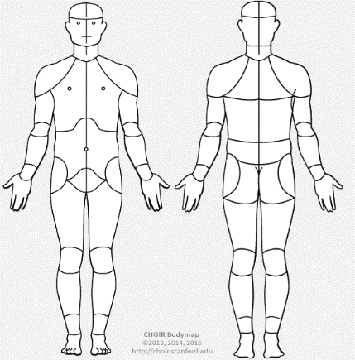

L

R

L

R

Thank you for your participation.